Tender Advertisment
Supply of Rice to the School of St Jude

Want to work with one of the largest charities of its kind in Africa? Do you have experience in supplying rice to NGO’s and non-profit organisations? Have you done work in a school environment? Does it sound like we’re talking about you… Keep reading!

About Us
The School of St Jude is a pioneering leader in charitable education within Africa. We are giving 1,800 students, quality education, 100’s of graduates’ access to higher education. St Jude’s is funded by generous supporters from around the world who make our mission of giving bright, poor Tanzanian students a free, quality education possible.

What you need
Interested parties are hereby invited to tender for the supply of the following; “The supply of rice for The School of St Jude, Sisia Campus, Moshono, Arusha”. Bidders are invited to submit their tenders for the supply of the above items.

Tender Reference: TENDER NO: TSOSJ/2023/Rice – May/03
Date 24th May 2023

- Quantity required
Tenders are invited to the School of St Jude, Moshono, Arusha, Tanzania for the supply of the following;
- 100,000 kg Kahama rice grade 2.1

- What you need to apply
To be eligible for consideration of your tender suppliers should submit the following:
- Name and postal & physical address of the company;
- Name of Director / Owner;
- A list of referees’ companies that you have supplied in the last twelve months (when supplied, contract value, location of the client and contact details;
- Valid Business license and any other applicable trading licences;
- VAT and Tax Identification Number (TIN) registration;
- Must be able to provide a Proforma Invoice, Tax Invoice, Delivery Note and legal EFD receipt. The Efd will be verified before the contract is awarded to the successful bidder.
- The price should include transportation, loading and unloading to our Sisia Campus;
- Tendered price shall be fixed for a duration advised by the bidder but such duration be not less than 90days; and
- Please submit tender as well as a quarter of a kilogram sample of the rice to be provided. The sample must be in a transparent packing bag and write your company name on the bag.

- Specifications and conditions
- Kahama rice grade 2.1

- Submission
All Tenders in one original copy, properly filled in, and enclosed in plain envelopes shall be submitted with the necessary documents not later than 13th June 2023 at 10:30am in a sealed envelope clearly marked
TENDER FOR SUPPLY OF RICE TO THE SCHOOL OF ST JUDE SISIA CAMPUS to the following physical address:

The Team Lead Purchasing
The School of St Jude
Sisia Campus
P.O. Box 11875
Arusha

- Opening of tenders
Tenders will be opened on 13th June 2023 at 11:00 am in public. All the Tenderers or their representatives are invited to attend the tender opening at St Jude’s Boardroom, Sisia Campus. Any of the following reasons will lead to disqualification; Late submission of tenders, electronic tenders, and tenders not received, will not be accepted for the tender opening ceremony for evaluation irrespective of the circumstances.

- Notification of outcome
Bidders shall be notified within 7 days of the tender opening. St Jude’s reserves the right to disclose how the outcome was obtained.

- Enquiries
Should you have any enquiries please contact:
Team Lead Purchasing
The School of St Jude
+255 693 141 235

- No Solicitation statement
St Jude’s conducts its activities in an honest, transparent and fair manner. All bidders will be given an equal opportunity and evaluated accordingly. Potential and/or any bidders shall not in any way attempt to influence the tendering process. Any form of solicitation in order for any bidder to be favored and/or for other bidders to be treated unfairly shall forthwith disqualify any bidder involved in such conduct.

- Adherence to all instruction
Bidders are hereby encouraged to adhere to all instructions as provided above. Failure to follow instructions or partial fulfillment of instructions shall forthwith be a disqualification.

- Quotations/Evaluation of bids
Quotations that are responsive, qualified and technically complaint will be ranked according to price. Award of contract will be made to the lowest price quotation by the issue of Purchase order.

- Payments
Payments will be made in accordance with any resulting order after completion of the school’s internal verification process on the quality of the rice supplied and after receipt of an invoice supported by a certificate of satisfactory completion/Goods receipt note.

Signed by;

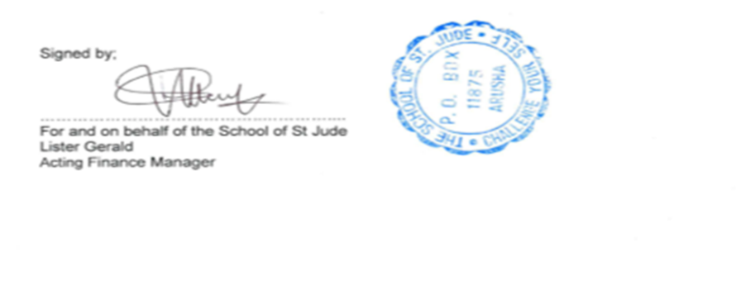
…………………………………..…………....
For and on behalf of the School of St Jude
Lister Gerald
Finance Manager

